CMSY++ assessment model
Deliverable Number: D3.6

Date 30.10.2026 | Final Version
Contributors: Maria Lazarina, Sophie Manousi, Aristea Zafeiropoulou, Athanassios Tsikliras
Visibility: Public

DOCUMENT INFORMATION

Grant Agreement | 101157456
Project Acronym | SURIMI
Project Title | Integration of innovative and reliable socio-ecological models and user-driven solutions into the Digital Twin Ocean, to facilitate what-if scenarios and decision support, under a co-creation approach.
Deliverable Number | D3.6
Work Package Number | WP3
Deliverable Title | CMSY++ assessment model: Ready to use, open source, data-limited assessment model, deposited in a public repository
Lead Partner | UOXF
Author(s) | Maria Lazarina, Sophie Manousi, Aristea Zafeiropoulou, Athanassios Tsikliras
Due Date | 31 October 2026
Submission Date | 30 October 2026
Dissemination Level | Public
Type of Deliverable | Other

Version | Summary of Changes
Version 0 | Initial Version
Version 1 | Shortening of text
Final Version | Addition of figures

SUMMARY
This deliverable presents CMSY++, a well-established data-limited stock-assessment model adapted for use within SURIMI under WP3 Socio-Ecological Models. CMSY++ estimates fisheries reference points, stock status and exploitation rates from catch data and, where available, abundance or catch-per-unit-effort (CPUE) information. This makes it suitable for assessing stocks for which conventional data-intensive methods cannot be applied.
The deliverable describes the purpose of CMSY++, its assessment workflow, the required inputs and the outputs generated by the model. CMSY++ can be applied in catch-only mode or, where abundance information is available, through the Bayesian Schaefer Model. The main outputs include estimates of Maximum Sustainable Yield (MSY), biomass relative to biomass at MSY ($\frac{B}{B_{MSY}}$), fishing mortality relative to fishing mortality at MSY ($\frac{F}{F_{MSY}}$), and associated uncertainty.
The SURIMI implementation builds on the stand-alone CMSY++ R version released in 2021 (Froese et al., 2021). The underlying assessment methods were retained, while operational adaptations were introduced to support automated execution within the SURIMI modelling workflow, including multi-stock processing, standardised input and output files, improved error handling and adjustments to output generation. The SURIMI-adapted implementation is made available through the SURIMI GitHub repository together with the supporting files.
CMSY++ is applied to stocks from the Northwestern Mediterranean and Aegean Sea case studies, while Anchovy Bay is included as an educational application based on simulated data. Within the SURIMI modelling framework, CMSY++ operates as a model service that receives case-study-specific catch and, where available, biomass or abundance information from the other models and returns annual estimates of stock status and exploitation. These outputs support the comparison of alternative management scenarios and are presented through the SURIMI Model Graphical User Interface.

CONTENTS
DOCUMENT INFORMATION 1
SUMMARY 2
1. MODEL PURPOSE 4
2. PROCESS OVERVIEW AND SCHEDULING DIAGRAMS 5
2.1. CMSY++ PROCESS OVERVIEW 5
2.2. CMSY++ EXECUTION WITHIN THE SURIMI MODELLING WORKFLOW 8
3. CONFIGURATION 9
3.1. CATCH_FILE.csv 10
3.2. ID_FILE.csv 11
3.3. AA_CMSY++.R 12
3.4. SUPPORTING FILES 13
4. INPUTS 13
4.1. BIOMASS 13
4.2. CATCH DISPOSITION 14
5. OUTPUTS 14
5.1. STOCK STATUS 14
5.2. EXPLOITATION RATE 14
5.3. ADDITIONAL CMSY++ OUTPUTS 15
6. REFERENCES 17
7. ANNEX 19

1. MODEL PURPOSE
Stock assessment constitutes a critical component of effective fisheries management, providing the scientific basis for evaluating stock status, determining sustainable exploitation levels and supporting management decisions that contribute to the conservation and sustainable use of marine resources. In fisheries management, Maximum Sustainable Yield (MSY), i.e. the highest long-term equilibrium catch that can be taken from a stock under prevailing environmental conditions without compromising its capacity to replenish (FAO, 2001), is a central reference point. Science-based management can maintain or rebuild exploited stocks to biomass levels capable of supporting MSY (Hilborn et al., 2020). However, sustainability remains highly variable among regions: 64.5% of assessed marine fish stocks are exploited within biologically sustainable levels, whereas only 35.1% of assessed stocks in the Mediterranean and Black Sea are considered biologically sustainable (Sharma et al., 2025), consistent with earlier evidence of widespread overfishing and depleted stock status in European fisheries (Froese et al., 2018).
CMSY++ (Froese et al., 2017, 2023) is a well-established data-limited stock assessment method and framework for assessing fisheries under limited data availability (Pons et al., 2020; Zhou et al., 2018; Bouch et al., 2021; Sharma et al., 2021). It is designed to estimate fisheries reference points, stock status and exploitation levels across different levels of data availability, from catch-only applications to assessments that combine catch time series with abundance indices. This is particularly relevant where conventional stock assessment approaches, which often require extensive biological, fisheries and survey information, cannot be applied because such data are limited or unavailable (Carruthers et al., 2014; Dimarchopoulou et al., 2024). These limitations are especially relevant in Mediterranean fisheries, where data availability is often constrained by the complexity of multispecies fisheries and heterogeneous monitoring systems (Stergiou et al., 2016; Froese et al., 2023).
CMSY++ uses catch histories, life-history information and assumptions regarding stock depletion, while abundance data can be incorporated when available to provide additional information for the assessment (Tsikliras and Froese, 2019; Ovando et al., 2021). The model provides estimates of the principal fisheries reference points, including MSY, biomass at MSY ($B_{MSY}$) and fishing mortality at MSY ($F_{MSY}$), together with stock-status indicators expressed as biomass relative to $B_{MSY}$ ($\frac{B}{B_{MSY}}$) and fishing mortality relative to $F_{MSY}$ ($\frac{F}{F_{MSY}}$). It also provides biomass and fishing-mortality trajectories over the assessment period and the associated uncertainty (Froese et al., 2017, 2023). These outputs provide a common basis for evaluating stock condition and fishing pressure across stocks with different levels of data availability.
Different assessment modes can be used depending on the available data. The Bayesian Schaefer Model is applied to stocks for which both catch and abundance data are available, while the catch-only CMSY method is applied when abundance information is not available. Together, these complementary modes allow CMSY++ to be applied across stocks differing in the type and amount of available information.
CMSY++ is openly available, computationally efficient and widely used in data-limited fisheries assessment (Froese et al., 2023). The framework has been applied across a broad range of species, ecosystems and data contexts, including assessments of data-limited fisheries in the Mediterranean and Black Sea (Demirel et al., 2020; Saygu et al., 2023). Its broad use in the fisheries science community, together with its open-source implementation and operational flexibility, further supports its suitability for SURIMI. The adoption of CMSY++ was also supported by expertise within the SURIMI consortium. Athanassios C. Tsikliras has contributed to the further development of CMSY++ (Froese et al., 2023) and to its application in fisheries assessments across European fisheries, particularly in the Mediterranean region (Froese et al., 2018; Tsikliras et al., 2021; Ferragut-Perello et al., 2023).
CMSY++ was therefore adopted as the stock-assessment component of the SURIMI model combination under Task 3.2 because it can provide comparable estimates of stock status and fishing pressure across stocks and case studies with heterogeneous data availability. Its application is supported by historical catch and landing series, species-specific life-history information from FishBase and SeaLifeBase (Froese and Pauly, 2024; Palomares and Pauly, 2024), and abundance indices available for some of the assessed stocks. Within SURIMI, CMSY++ provides a common basis for summarising stock condition across regions and supports indicator development, comparative analyses and management-oriented applications. In addition, its R-based implementation facilitates integration into the SURIMI interoperability framework and supports its use in automated multi-model workflows.

2. PROCESS OVERVIEW AND SCHEDULING DIAGRAMS

2.1. CMSY++ PROCESS OVERVIEW
CMSY++ is based on the Schaefer surplus-production model, which adapts the logistic population growth model of Verhulst (1838) to biomass dynamics in exploited fish populations (Schaefer, 1954). It follows a sequential assessment workflow in which catch information, species life-history characteristics and, where available, abundance information are combined to estimate stock dynamics and fisheries reference points. At its core, the framework seeks to identify combinations of intrinsic population growth rate (r) and carrying capacity (k) that are consistent with the observed catch history, the available biological information and plausible biomass trajectories. The assessment can therefore be viewed as a filtering process in which possible combinations of model parameters and associated biomass trajectories are evaluated against the observed data and biological constraints, with combinations that imply implausible stock dynamics receiving little or no support. Given that catch data alone cannot uniquely determine both r and k, the estimation workflow begins by defining informative priors for the main quantities required by the model: r, MSY, k, and relative biomass ($\frac{B}{k}$). The workflow is sequential but interconnected (Figure 1).
Prior information on population productivity is used to define plausible values for (r) either by using reliable stock-specific information (with the empirical relationships r ≈ 2M and r ≈ 2FMSY), or, when such information is not available, by assigning the prior range according to species resilience from FishBase (Froese and Pauly, 2024) for fishes and SeaLifeBase (Palomares and Pauly, 2024) for invertebrates. The corresponding ranges are 0.015-0.1 for very low, 0.05-0.5 for low, 0.2-0.8 for medium and 0.6-1.5 for high resilience (Froese et al., 2017; Froese and Pauly, 2024; Palomares and Pauly, 2024). The historical catch series is used to derive a heuristic prior for MSY, which is combined with the prior range for r to obtain the carrying capacity (k) prior. If the catch time series is approximately flat or increasing and the maximum catch occurred within the last five years of the series, the mean of the three highest catches is used as the prior for MSY. If catches declined following a historical peak, the MSY prior is approximated as three-quarters of the mean of the five highest catches. The MSY prior is then combined with the prior range for r to derive the corresponding prior range for carrying capacity (k) using the Schaefer equilibrium relationship:
$MSY=\frac{rk}{4}$ and therefore: $k=\frac{4MSY}{r}.$
Prior information on relative biomass ($\frac{B}{k}$) is specified for the beginning of the catch series, an optional intermediate year and the final year. These relative-biomass priors reflect assumptions about the exploitation history of the stock and constrain the range of depletion trajectories considered plausible during model estimation. CMSY++ provides five depletion classes with suggested $\frac{B}{k}$ranges of 0.75-1.00 for very low depletion, 0.40-0.80 for low depletion, 0.20-0.60 for medium depletion, 0.01-0.40 for strong depletion and 0.01-0.20 for very strong depletion. Where direct information on stock depletion is not available, CMSY++ can use the trained artificial neural network included with the framework to suggest default relative-biomass priors from characteristics of the catch time series. These priors do not determine the final estimates directly but define the biologically plausible parameter space within which the assessment is carried out. This is particularly important in data-limited assessments because catch data alone cannot uniquely identify all population parameters and a given catch time series may be compatible with different combinations of r and k.
When only catch information is available, CMSY++ is applied in catch-only mode and estimates stock dynamics using the catch series together with the biologically informed priors. When abundance information is also available, CMSY++ is applied as the Bayesian Schaefer Model (BSM), in which catch data and abundance indices are fitted jointly within the same modelling framework. Abundance data may include catch-per-unit-effort (CPUE), survey indices, acoustic estimates or other indicators of relative stock abundance. In the BSM mode, a catchability coefficient links the abundance index to the modelled biomass trajectory. The choice between the catch-only and BSM modes depends not only on the presence of abundance data, but also on their quality and relevance to the assessment.
Once the assessment mode has been determined, the priors are combined with the catch data and, where available, abundance indices within the Bayesian estimation framework. Unlike the Monte Carlo filtering used in the original CMSY method, CMSY++ implements the modified Schaefer surplus-production model as a Bayesian state-space model. Estimation is carried out through Markov Chain Monte Carlo (MCMC) sampling using JAGS (Just Another Gibbs Sampler, Plummer, 2017), which is called from the R environment, producing posterior distributions for the model parameters, biomass trajectories and derived stock-status quantities.
Within this framework, possible combinations of r and k are evaluated together with their associated biomass trajectories. CMSY++ accounts for the negative relationship between r and k through a joint prior distribution, and biomass is propagated through the observed catch time series for each plausible parameter combination. The resulting trajectories are evaluated against the catch history, relative-biomass priors and biological constraints. Trajectories implying stock collapse, biomass exceeding carrying capacity or depletion patterns inconsistent with the specified priors are penalised or downweighted, and the combinations remaining consistent with the available information define the posterior distribution of plausible population dynamics.
The posterior samples generated through MCMC are then used to estimate annual biomass and fishing mortality and to derive the principal fisheries reference points. These include MSY, biomass at MSY ($B_{MSY}$) and fishing mortality at MSY ($F_{MSY}$). Stock condition is expressed through biomass relative to BMSY ($\frac{B}{B_{MSY}}$), while exploitation rate is expressed through fishing mortality relative to $F_{MSY}$ ($\frac{F}{F_{MSY}}$). Posterior distributions are summarised using medians and percentile-based uncertainty intervals, allowing uncertainty in the model parameters and reconstructed stock trajectories to be propagated into the reported stock-status indicators.
Overall, the assessment process moves from the preparation of catch, biological and abundance information, through the specification of biologically informed priors and Bayesian estimation, to the evaluation of plausible r-k combinations, reconstruction of biomass and fishing-mortality trajectories and derivation of fisheries reference points and stock-status indicators. This sequence is implemented within the CMSY++ R script, which performs data preparation, prior construction, model estimation, post-processing and generation of numerical and graphical results.
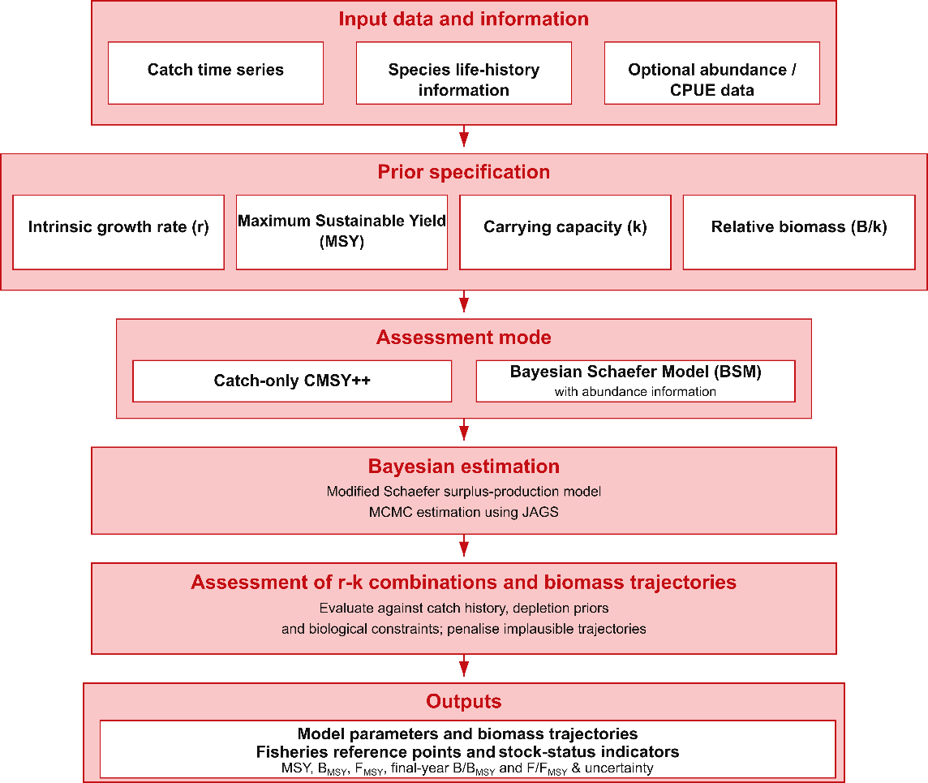
Figure 1. Schematic representation of the CMSY++ workflow from data input and prior specification to model estimation and the derivation of key fisheries reference points and stock-status indicators.

2.2. CMSY++ EXECUTION WITHIN THE SURIMI MODELLING WORKFLOW
Within the SURIMI modelling framework, CMSY++ provides the stock-assessment component and operates alongside ecological, fisheries and socioeconomic models. The interaction of CMSY++ with the other models depends on the configuration of each case study. The three case studies considered here are the Northwestern Mediterranean, the Aegean Sea and Anchovy Bay. In the Northwestern Mediterranean, catch data can be provided by POSEIDON, while Ecopath with Ecosim provides biomass and catch information to CMSY++ (Figure 2). In the Aegean Sea biomass and catch data are provided by the MICE model. These data are transferred to the CMSY++ Stock Assessment service through the SURIMI Controller, which coordinates communication and data exchange among the model services.
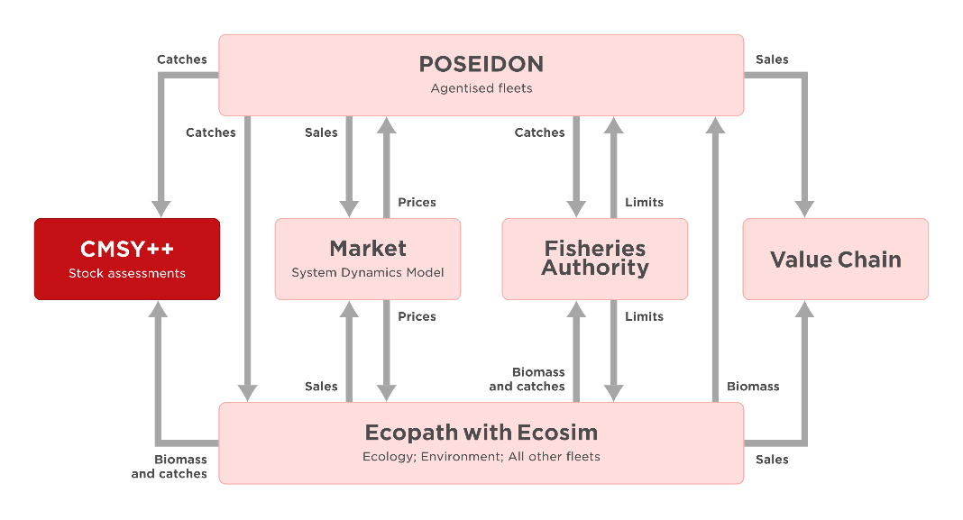
Figure 2. Model interactions and data exchanges within the SURIMI modelling framework.

The CMSY++ assessment model is implemented as the Stock Assessment service within the SURIMI simulation framework. It combines an R-based assessment engine with a Python service responsible for experiment management, data preparation, model execution and delivery of results. Communication with the other SURIMI models is coordinated through the SURIMI Controller using gRPC and shared Protobuf protocol.
Each experiment involves two separate CMSY++ assessments. The historical assessment is run at initialisation using historical catch data and, where available, abundance data. The 95% interval of the final-year $\frac{B}{B_{MSY}}$ estimate is converted into the prior range for relative biomass (B/k) at the start of the simulated period. During the simulation, monthly biomass and catch data are transferred through the Controller and aggregated into annual stock-level time series. At finalisation, CMSY++ is executed using simulated data. The resulting annual estimates of stock status ($\frac{B}{B_{MSY}}$) and exploitation rate ($\frac{F}{F_{MSY}}$) are returned to the Controller and made available to the wider SURIMI modelling framework. The sequence diagram in Figure 3 depicts this interaction, including the exchange of simulated data and CMSY++ assessments performed at initialisation and finalisation. Each experiment can include multiple simulations.

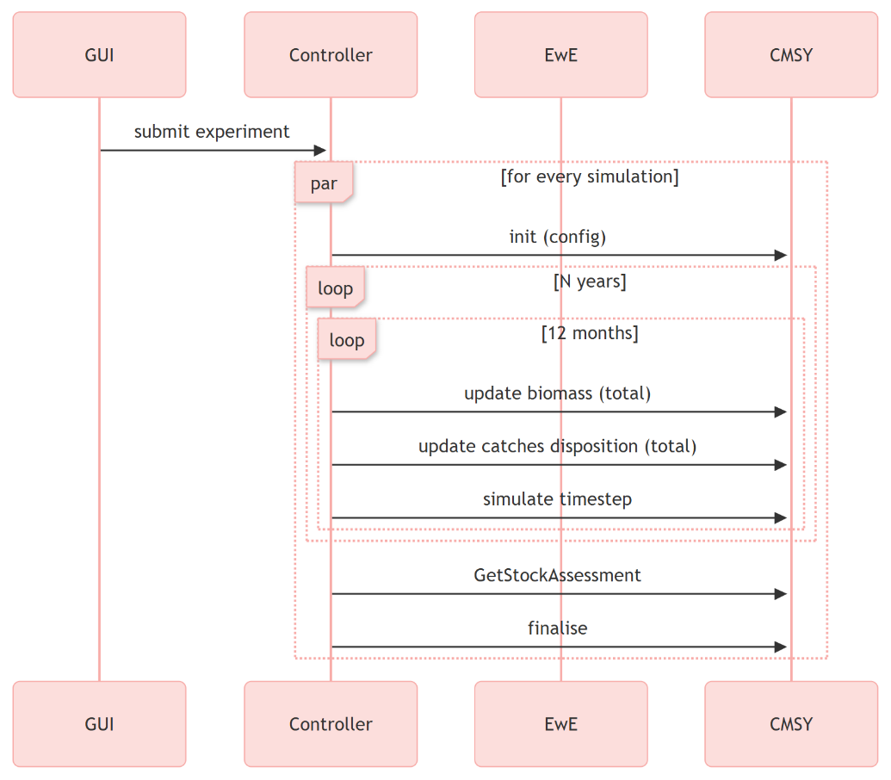
Figure 3. CMSY++ execution within the SURIMI workflow, showing the exchange of simulation data through the Controller and the assessments performed at initialisation and finalisation.

3. CONFIGURATION
The Stock Assessment service requires scenario-specific configuration files to perform its calculations. The scenario (northwestern_med, anchovy_bay or aegean_sea) is specified at experiment initialisation. The corresponding files are downloaded from the S3 bucket into the experiment workspace, where they are used by the CMSY++ assessment engine.
The following files are required:
- catch_file.csv: Working catch and abundance file used for the historical assessment and subsequently recreated to store simulated annual observations. A file named catch_file_original.csv is also included retaining the historical catch data for reference and comparison.
- id_file.csv: Stock identification, assessment periods, biological information and prior settings. A file named id_file_original.csv is also included as an unchanged reference copy of the original stock configuration, supporting traceability and reproducibility
- AA_CMSY++.R: R script implementing the CMSY++ and BSM assessments
- ffnn.bin: Pre-trained neural networks used to derive default relative-biomass priors
- r2jags.bug: JAGS model file required by the assessment engine
During the initialisation, the catch_file.csv, catch_file_original.csv and id_file.csv are filtered to the species included in the experiment. The first CMSY++ assessment is implemented with the filtered catch_file.csv and the id_file.csv. After the execution of the historical assessment, the catch_file.csv used is renamed catch_file_historical.csv. Also, a copy of the id_file is stored as id_file_historical.csv, retained as an unchanged reference copy for traceability and reproducibility. The output of the historical assessment is used to update the working id_file.csv for the simulated assessment, and a new empty catch_file.csv is created to store only the annual catch and abundance data generated during the simulation. The filtered catch_file_original.csv retains the full observed time series for the selected species and is used for comparison with the simulated data.

3.1. CATCH_FILE.csv
The catch file is a comma-delimited table containing the annual catch data for each stock and is named catch_file.csv. It includes four columns: a stock identifier (Stock), the calendar year (yr), the annual catch in kilograms (ct), and an optional abundance or CPUE column (bt). When no abundance data are available, the bt column is filled with missing values (NA). Table 1 provides a summary of the structure of catch_file.csv.
Table 1. Variables included in the catch_file.csv input file.
Variable | Type | Description
Stock | string | Unique stock identifier. This field must match exactly the corresponding Stock field in the stock-identification file
yr | numeric | Calendar year of the catch observation
ct | numeric | Annual catch in kilograms. Missing values or zeroes representing missing catch data are not accepted and must be filled or interpolated before running the assessment.
bt | numeric | Optional abundance, CPUE or abundance-based index. When no abundance data are available, this field is set to NA. Gaps in bt are acceptable.

Missing abundance observations are represented by “NA”. The catch time series must be continuous, with no missing years, and must span at least ten consecutive years. Missing or zero values are not acceptable in the catch column and must be replaced by interpolation prior to analysis. When a single year is missing, substitution with the mean value of adjacent values is generally adequate. When two or more consecutive years are missing, simple interpolation is insufficient and gap-filling should be approached with caution, drawing on ancillary information, historical records, or expert knowledge of the stock and fishery to produce a plausible reconstruction. Gaps in the abundance series are acceptable, as abundance data may be available for fewer years than catch data. However, for the BSM to run, an adequate number of abundance observations must be available. An example from catch_file.csv for European hake (HKE) in the Aegean Sea is shown in Table 2.

Table 2. Example from catch_file.csv for European Hake (HKE) in the Aegean Sea.
Stock | yr | ct | bt
HKE | 1950 | 1074100 | NA
HKE | 1951 | 878810 | NA
⋮ | ⋮ | ⋮ | ⋮
HKE | 1993 | 4493200 | NA
HKE | 1994 | 6134600 | 34.62161
⋮ | ⋮ | ⋮ | ⋮
HKE | 2021 | 2901550 | 39.64986
HKE | 2022 | 3192490 | 56.65822

3.2. ID_FILE.csv
The stock-identification file is a comma-delimited table and is named id_file.csv. It contains one row for each stock included in the catch file. It is the main file through which the user defines the stock metadata, assessment period, biological priors, abundance-data settings and optional external reference points. The Stock field must match exactly the corresponding Stock field in the catch file, as it is the link identifier of the two input files. Table 3 provides a summary of the structure of id_file.csv. An abbreviated example of the corresponding id_file.csv entry is shown in Table 4. The historical CMSY++ assessment is used to update the lower and upper bound of the prior range B/k used for the second assessment using the simulated data.
Table 3. Variables included in the id_file.csv input file.
Variable | Type | Description
Continent | string | Continent of the fishing area, e.g. Europe.
Region | string | Broader catch area or assessment region, e.g. West Mediterranean.
Subregion | string | Sea basin or sub-area, e.g. North_Spain.
Stock | string | Unique stock identifier matching Stock column in catch file, e.g. ALB, AMB or ANE.
Group | string/NA | Functional or ecological group assigned to the species
Name | string | Common name of the species, e.g. Albacore, Greater amberjack or European anchovy.
ScientificName | string | Scientific name of the species, e.g. Thunnus alalunga
SpecCode | string | Species/stock code used in the file, e.g. Albacore_North_Spain.
Source | string | Source of the biological or assessment information, e.g. a FishBase or SeaLifeBase URL.
MinOfYear | numeric | First year for which catch data are available, e.g. 2000 for ALB or 1945 for ANE.
MaxOfYear | numeric | Last year for which catch data are available
StartYear | numeric | First year of the catch series used in the assessment
EndYear | numeric | Last year of the catch series used in the assessment
Flim | numeric | Limit fishing mortality reference point
Fpa | numeric | Precautionary fishing mortality reference point
Blim | numeric | Limit biomass reference point
Bpa | numeric | Precautionary biomass reference point
Bmsy | numeric | Biomass at MSY
MSYBtrigger | numeric | Biomass trigger reference point
Fmsy | numeric | Fishing mortality at MSY
last_F | numeric | Fishing mortality in the most recent assessment year
Resilience | string | Resilience category of the species (High, Medium, Low, Very low)
r.low | numeric | Lower bound of the prior range for (r), e.g. 0.28 for ALB
r.hi | numeric | Upper bound of the prior range for (r), e.g. 0.64 for ALB
stb.low | numeric | Lower bound of the prior range B/k at the start of the assessment period.
stb.hi | numeric | Upper bound of the prior range for B/k at the start of the assessment period.
int.yr | numeric | Optional intermediate year for which a biomass prior is specified
intb.low | numeric | Lower bound of the prior range for B/k in the intermediate year.
intb.hi | numeric | Upper bound of the prior range for B/k in the intermediate year.
endb.low | numeric | Lower bound of the prior range for B/k at the end of the assessment period.
endb.hi | numeric | Upper bound of the prior range for B/k at the end of the assessment period.
btype | string | Indicates whether the bt column contains biomass or CPUE data. Accepted values are biomass, CPUE, and None.
e.creep | numeric | Assumed annual percentage increase in fishing efficiency for commercial CPUE data.
force.cmsy | logical | Indicates whether use CMSY++ catch-only results instead of available BSM results.
Comments | string | Free-text notes on data quality, assumptions or non-default settings.
IGS_ecopath | string | Indicator for linkage with Ecopath with Ecosim, where applicable.

Table 4. Example of the id_file.csv for the European Hake (HKE) in the Aegean Sea.
Stock | ScientificName | StartYear | EndYear | Resilience | r.low | r.hi | btype | force.cmsy
HKE | Merluccius merluccius | 1950 | 2022 | Medium | 0.32 | 0.72 | CPUE | FALSE

3.3. AA_CMSY++.R
The AA_CMSY++.R script implements the CMSY++ stock-assessment framework. The SURIMI implementation builds on the CMSY++ version distributed by Froese et al. (2021) as the main script CMSY++16.R, together with supporting files and user documentation. The original stand-alone CMSY++ implementation is publicly available through the GEOMAR OceanRep repository (https://oceanrep.geomar.de/id/eprint/52147/) and the official CMSY++ GitHub repository (https://github.com/SISTA16/cmsyPlusPlus) together with the User Guide for CMSY++ and example data for testing the model. For use within SURIMI, the stand-alone implementation was adapted for automated execution within the wider modelling framework. It retained the underlying CMSY++ assessment methodology but modified the operational layer to support automated multi-stock and scenario-based execution, standardised file handling, improved robustness and integration within the SURIMI modelling framework. This was done by enabling parallel stock processing when feasible, standardising input and output handling, using stock-specific temporary model files, and enhancing validation and fallback procedures. The SURIMI release includes the modified CMSY++ assessment script and the supporting files required for its execution. The source code is maintained in the SURIMI GitHub repository: https://github.com/SURIMI-Project/SURIMI-CMSY .
The script applies the catch-only CMSY method and, where sufficient abundance observations are available, the Bayesian Schaefer Model (BSM). Bayesian estimation is performed through JAGS to reconstruct biomass and fishing mortality trajectories and estimate fisheries reference points, including MSY, $B_{MSY}$ and$F_{MSY}$. The resulting stock-level estimates and annual trajectories are written to CMSY_output.csv.
Within SURIMI, the Python Stock Assessment service executes the script twice: first using historical fisheries data and subsequently using the annual catch and biomass data generated during the simulation. Execution requires R and JAGS (Just Another Gibbs Sampler, Plummer, 2017) together with the R packages R2jags (Su and Yajima, 2015), coda (Plummer et al., 2015), mvtnorm (Genz et al., 2021), neuralnet (Fritsch et al., 2019), conicfit (Gama and Chernov, 2015), parallel (R Core Team, 2025), foreach and doParallel (Microsoft Corporation and Weston, 2022), snpar, and gplots (Warnes et al., 2016). The package snpar, used for non-parametric residual diagnostics when abundance or CPUE data are available, is installed from its GitHub repository using devtools (Wickham et al., 2022).

3.4. SUPPORTING FILES
The CMSY++ assessment engine requires two supporting files. The ffnn.bin file contains pre-trained feed-forward neural networks used to estimate default relative-biomass ($\frac{B}{k_{ }}$) priors for the beginning, intermediate and final years of the assessment period when these are not explicitly provided in id_file.csv. The r2jags.bug file contains the JAGS model specification used for Bayesian estimation. During execution, stock-specific temporary copies are created to allow multiple stocks to be processed without conflicts between concurrent JAGS runs.

4. INPUTS
The Stock Assessment service receives monthly biomass and catch data generated by EwE and POSEIDON (only catch data) or MICE, depending on the case-study scenario, and transferred by the SURIMI Controller. The data are provided by species and spatial grid cell through the UpdateBiomassStatistics and UpdateCatchDispositionStatistics methods, respectively. The Python service accumulates these values and converts them into the annual stock-level time series required by CMSY++.

4.1. BIOMASS
The Controller sends biomass data for each species, organised into spatial grids. For each grid cell, the Stock Assessment service receives mean biomass (biomass.mean) and accumulates it by species and cell throughout the simulation year. At the end of each year, the service calculates the mean of the positive accumulated cell values for each stock. This value is recorded in the bt column of catch_file.csv and used as the annual abundance index in the subsequent CMSY++ assessment. If no positive biomass values are available, bt is recorded as “NA”.

4.2. CATCH DISPOSITION
The Stock Assessment service receives monthly catch data from the SURIMI Controller, originating from EwE, POSEIDON or MICE depending on the case-study scenario. Gross catch (gross_catch.mean) is accumulated by species and grid cell throughout the simulation year. At the end of each year, the accumulated values are summed across grid cells for each stock and recorded as annual catch (ct) in catch_file.csv. A calculated catch of zero is retained as 0, and “NA” indicates that no catch data were available for the stock.

5. OUTPUTS
The CMSY++ assessment produces estimates of population parameters and fisheries reference points, reconstructed annual biomass and exploitation trajectories, and associated uncertainty for each assessed stock. These results are compiled in CMSY_output.csv, with one row per stock and separate columns containing the annual estimates. The Python service processes the numerical output and returns annual estimates for each stock of stock status, expressed as biomass relative to the biomass associated with maximum sustainable yield ($\frac{B}{B_{MSY}}$), and exploitation rate, expressed as fishing mortality relative to the fishing mortality associated with maximum sustainable yield ($\frac{F}{F_{MSY}}$). These stock-specific annual time series are returned to the SURIMI Controller through the GetStockAssessment method.

5.1. STOCK STATUS
Stock status is expressed as biomass relative to the biomass associated with maximum sustainable yield ($\frac{B}{B_{MSY}}$). It describes the condition of a stock by comparing its estimated biomass in a given year (B) with the biomass reference point ($B_{MSY}$). A value of 1 indicates that biomass is at $B_{MSY}$. Values below 1 indicate biomass below this reference point, whereas values above 1 indicate biomass above it. The Python service calculates annual $\frac{B}{B_{MSY}}$values using the corresponding biomass estimates and $B_{MSY}$ reported in CMSY_output.csv. Each annual estimate is returned through the stock_status field of the StockAssessment response, together with the corresponding species and year.

5.2. EXPLOITATION RATE
Exploitation rate is expressed as fishing mortality relative to the fishing mortality associated with maximum sustainable yield ($\frac{F}{F_{MSY}}$). It describes fishing pressure on a stock by comparing estimated fishing mortality in a given year (F) with the fishing mortality reference point ($F_{MSY}$). A value of 1 indicates that fishing mortality is at $F_{MSY}$. Values above 1 indicate fishing mortality above this reference point, whereas values below 1 indicate fishing mortality below it. The Python service extracts the annual $\frac{F}{F_{MSY}}$estimates directly from the corresponding F.Fmsy columns in CMSY_output.csv. Each annual estimate is returned through the exploitation field of the StockAssessment response, together with the corresponding species and year.

5.3. ADDITIONAL CMSY++ OUTPUTS
In addition to the stock-status and exploitation indicators returned to the SURIMI Controller, CMSY_output.csv contains the broader CMSY++ numerical output, including model parameters, reference points, uncertainty estimates and annual trajectories. The complete variable dictionary is provided in Annex Table A. For each assessed stock, the original CMSY++ can generate a PDF report summarising the assessment results. The report includes a management summary figure (Figure 4I) showing a series of indicators over the assessment period: (i) annual catches together with the estimated MSY and its uncertainty range, (ii) biomass relative to $B_{MSY}$, along with its uncertainty range, (iii) exploitation rate $\frac{F}{F_{MSY}}$, and (iv) the relationship between $\frac{B}{B_{MSY}}$ and $\frac{F}{F_{MSY}}$. The report also presents the main reference points and the estimated final-year stock status, including $F_{MSY}$, MSY and $B_{MSY}$, final-year biomass and fishing mortality and the corresponding ratios $B/B_{MSY}$and $F/F_{MSY}$. Additionally, there is a six-panel summary figure (Figure 4II) depicting the catch series, candidate and retained r-k combinations, relative biomass, exploitation rate and catch relative to MSY. Finally, the original script exports four graphical outputs as individual files: the management summary figure, the six-panel assessment summary, the r-k diagnostics plots and the Kobe plot (Figure 4III). The Kobe plot presents $\frac{B}{B_{MSY}}$ on the horizontal axis and $\frac{F}{F_{MSY}}$ on the vertical axis, with reference lines at 1 defining four stock-status quadrants: green ($\frac{B}{B_{MSY}}>1, \frac{F}{F_{MSY}}<1$), red ($\frac{B}{B_{MSY}}<1, \frac{F}{F_{MSY}}>1$), yellow ($\frac{B}{B_{MSY}}<1, \frac{F}{F_{MSY}}<1$) , and orange ($\frac{B}{B_{MSY}}>1, \frac{F}{F_{MSY}}>1$). Different symbols mark the first, intermediate and final year of the assessment. The PDF report and the graphical outputs are disabled in the SURIMI implementation.

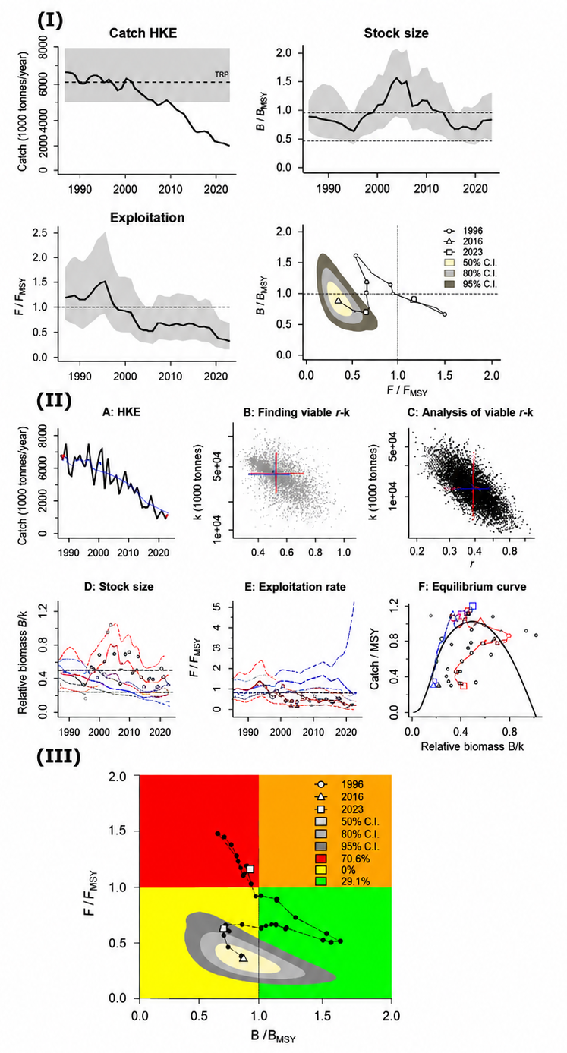

Figure 4. Graphical outputs generated by the original CMSY++ script for European hake in the Northwestern Mediterranean: (I) the management summary showing annual catches with MSY, biomass relative to $B_{MSY}$, exploitation rate and the stock-status trajectory, (II) the assessment summary showing the catch series, candidate and retained r-k combinations, relative biomass, exploitation rate and the relationship between relative biomass and catch relative to MSY, and (III) the Kobe plot showing the annual stock-status trajectory, selected assessment years and the 50%, 80% and 95% credible regions around the final-year estimate.

6. REFERENCES
Bouch, P., Minto, C., & Reid, D. G. (2021). Comparative performance of data-poor CMSY and data-moderate SPiCT stock assessment methods when applied to data-rich, real-world stocks. ICES Journal of Marine Science, 78(1), 264–276. https://doi.org/10.1093/icesjms/fsaa220
Carruthers, T. R., Punt, A. E., Walters, C. J., MacCall, A., McAllister, M. K., Dick, E. J., & Cope, J. M. (2014). Evaluating methods for setting catch limits in data-limited fisheries. Fisheries Research, 153, 48–68. https://doi.org/10.1016/j.fishres.2013.12.014
Demirel, N., Zengin, M., & Ulman, A. (2020). First large-scale eastern Mediterranean and Black Sea stock assessment reveals a dramatic decline. Frontiers in Marine Science, 7, Article 103. https://doi.org/10.3389/fmars.2020.00103
Dimarchopoulou, D., Tsikliras, A. C., Froese, R., & Pauly, D. (2024). Fish stocks. In S. M. Scheiner (Ed.), Encyclopedia of biodiversity (3rd ed., Vol. 2, pp. 388–403). Elsevier. https://doi.org/10.1016/B978-0-12-822562-2.00001-3
FAO. (2001). FAO fisheries glossary. Food and Agriculture Organization of the United Nations.
Ferragut-Perello, F., Ramírez-Amaro, S., Tsikliras, A. C., Petit-Marty, N., Dimarchopoulou, D., Massutí, E., … Ordines, F. (2023). Exploitation and conservation status of the thornback ray (Raja clavata) in the Balearic Islands, Northwestern Mediterranean. Fishes, 8(2), Article 117. https://doi.org/10.3390/fishes8020117
Fritsch, S., Guenther, F., & Wright, M. N. (2019). neuralnet: Training of neural networks (R package version 1.44.2). https://doi.org/10.32614/CRAN.package.neuralnet
Froese, R., Demirel, N., Coro, G., Kleisner, K. M., & Winker, H. (2017). Estimating fisheries reference points from catch and resilience. Fish and Fisheries, 18(3), 506–526. https://doi.org/10.1111/faf.12190
Froese, R., Demirel, N., Coro, G., & Winker, H. (2021). User guide for CMSY++. GEOMAR Helmholtz Centre for Ocean Research Kiel.
Froese, R., & Pauly, D. (2024). FishBase. FishBase Consortium. https://www.fishbase.org
Froese, R., Winker, H., Coro, G., Demirel, N., Tsikliras, A. C., Dimarchopoulou, D., … Matz-Lück, N. (2018). Status and rebuilding of European fisheries. Marine Policy, 93, 159–170. https://doi.org/10.1016/j.marpol.2018.04.018
Froese, R., Winker, H., Coro, G., Palomares, M. L. D., Tsikliras, A. C., Dimarchopoulou, D., … Pauly, D. (2023). New developments in the analysis of catch time series as the basis for fish stock assessments: The CMSY++ method. Acta Ichthyologica et Piscatoria, 53, 173–189. DOI 10.3897/aiep.53.105910
Gama, J., & Chernov, N. (2015). conicfit: Algorithms for fitting circles, ellipses and conics based on the work by Prof. Nikolai Chernov. R Foundation for Statistical Computing, Vienna, Austria.
Genz, A., Bretz, F., Miwa, T., Mi, X., Leisch, F., Scheipl, F., & Hothorn, T. (2021). mvtnorm: Multivariate normal and t distributions (R package version 1.1-2). https://CRAN.R-project.org/package=mvtnorm
Hilborn, R., Amoroso, R. O., Anderson, C. M., Baum, J. K., Branch, T. A., Costello, C., … Ye, Y. (2020). Effective fisheries management instrumental in improving fish stock status. Proceedings of the National Academy of Sciences of the United States of America, 117(4), 2218–2224. https://doi.org/10.1073/pnas.1909726116
Microsoft Corporation, & Weston, S. (2022). doParallel: Foreach parallel adaptor for the parallel package (R package). https://CRAN.R-project.org/package=doParallel
Ovando, D., Hilborn, R., Monnahan, C., Rudd, M., Sharma, R., Thorson, J. T., … Ye, Y. (2021). Improving estimates of the state of global fisheries depends on better data. Fish and Fisheries, 22(6), 1377–1391. https://doi.org/10.1111/faf.12593
Palomares, M. L. D., & Pauly, D. (2024). SeaLifeBase. SeaLifeBase Project. https://www.sealifebase.org
Plummer, M. (2017). JAGS version 4.3.0 user manual.
Plummer, M., Best, N., Cowles, K., Vines, K., Sarkar, D., Bates, D., Almond, R., & Magnusson, A. (2020). Package “coda”. Mirror.Las.Iastate.Edu. https:// cran.r-project.org/web/packages/coda/coda.pdf
Pons, M., Cope, J. M., & Kell, L. T. (2020). Comparing performance of catch-based and length-based stock assessment methods in data-limited fisheries. Canadian Journal of Fisheries and Aquatic Sciences, 77(6), 1026–1037. https://doi.org/10.1139/cjfas-2019-0276
R Core Team. (2025). R: A language and environment for statistical computing. R Foundation for Statistical Computing.
Saygu, İ., Akoglu, E., Gül, G., Bedikoğlu, D., & Demirel, N. (2023). Fisheries impact on the Sea of Marmara ecosystem structure and functioning during the last three decades. Frontiers in Marine Science, 9, Article 1076399. https://doi.org/10.3389/fmars.2022.1076399
Schaefer, M. B. (1954). Some aspects of the dynamics of populations important to the management of the commercial marine fisheries. Bulletin of the Inter-American Tropical Tuna Commission, 1(2), 27–56.
Sharma, R., Barange, M., Agostini, V., Barros, P., Gutierrez, N. L., Vasconcellos, M., … Levontin, P. (2025). Review of the state of world marine fishery resources-2025. Food and Agriculture Organization of the United Nations.
Sharma, R., Winker, H., Levontin, P., Kell, L., Ovando, D., Palomares, M. L. D., … Ye, Y. (2021). Assessing the potential of catch-only models to inform on the state of global fisheries and the UN’s Sustainable Development Goals. Sustainability, 13(11), Article 6101. https://doi.org/10.3390/su13116101
Stergiou, K. I., Somarakis, S., Triantafyllou, G., Tsiaras, K. P., Giannoulaki, M., Petihakis, G., … Tsikliras, A. C. (2016). Trends in productivity and biomass yields in the Mediterranean Sea large marine ecosystem during climate change. Environmental Development, 17, 57–74. https://doi.org/10.1016/j.envdev.2015.09.001
Su, Y.-S., & Yajima, M. (2015). R2jags: Using R to run JAGS (R package version 0.8-9). https://doi.org/10.32614/CRAN.package.R2jags
Tsikliras, A. C., & Froese, R. (2019). Maximum sustainable yield. In B. D. Fath (Ed.), Encyclopedia of ecology (2nd ed., Vol. 1, pp. 108–115). Elsevier. https://doi.org/10.1016/B978-0-12-409548-9.10601-3
Tsikliras, A. C., Touloumis, K., Pardalou, A., Adamidou, A., Keramidas, I., Orfanidis, G. A., … Koutrakis, M. (2021). Status and exploitation of 74 unassessed demersal fish and invertebrate stocks in the Aegean Sea, Greece, using abundance and resilience. Frontiers in Marine Science, 7, Article 578601. https://doi.org/10.3389/fmars.2020.578601
Verhulst, P.-F. (1838). Notice sur la loi que la population suit dans son accroissement. Correspondance Mathématique et Physique, 10, 113–121.
Warnes, G. R., Bolker, B., Bonebakker, L., Gentleman, R., Huber, W., Liaw, A., … Galili, T. (2016). gplots: Various R programming tools for plotting data (R package). https://CRAN.R-project.org/package=gplots
Wickham, H., Hester, J., Chang, W., & Hester, M. J. (2022). Package ‘devtools’. R Package, Version, 2(4).
Zhou, S., Punt, A. E., Smith, A. D. M., Ye, Y., Haddon, M., Dichmont, C. M., & Smith, D. C. (2018). An optimized catch-only assessment method for data-poor fisheries. ICES Journal of Marine Science, 75(3), 964–976. https://doi.org/10.1093/icesjms/fsx226

7. ANNEX

Table A. Summary of variables included in the CSV output of the CMSY++
Variable | Type | Description
Group | string | Functional group of the species
Region | string | Broader geographical area of the stock.
Subregion | string | Geographical subdivision within the broader area of the stock.
Name | string | Common name of the assessed species.
SciName | string | Scientific name of the assessed species.
Stock | string | Stock identifier linking the output to the input catch and id files
start.yr | numeric | First year included in the assessment.
end.yr | numeric | Final year included in the assessment.
start.yr.new | numeric | Suggested alternative start year when low initial catches create ambiguity in the biomass prior
btype | string | Type of abundance information used in the assessment.
N bt | numeric | Number of years with abundance or CPUE observations.
start.yr.cpue | numeric | First year represented in the abundance or CPUE series.
end.yr.cpue | numeric | Final year represented in the abundance or CPUE series.
min.cpue | numeric | Minimum abundance or CPUE index value observed.
max.cpue | numeric | Maximum abundance or CPUE index value observed.
min.yr.cpue | numeric | Year in which the minimum abundance or CPUE value is observed.
max.yr.cpue | numeric | Year in which the maximum abundance or CPUE value is observed.
endbio.low | numeric | Lower bound of the prior range for B/k in the final assessment year.
endbio.hi | numeric | Upper bound of the prior range for B/k in the final assessment year.
q.prior.low | numeric | Lower bound of the catchability prior used in the BSM assessment.
q.prior.hi | numeric | Upper bound of the catchability prior used in the BSM assessment.
MaxCatch | numeric | Maximum annual catch observed during the assessment period.
MSY_prior | numeric | MSY prior derived from the catch history.
MeanLast5RawCatch | numeric | Mean annual catch during the final five years of the assessment period.
SDLast5RawCatch | numeric | Standard deviation of annual catch during the final five years.
LastCatch | numeric | Catch recorded in the final assessment year.
MinSmoothCatch | numeric | Minimum value of the smoothed catch series.
MaxSmoothCatch | numeric | Maximum value of the smoothed catch series.
MeanSmoothCatch | numeric | Mean value of the smoothed catch series.
gMeanPrior_r | numeric | Geometric mean of the prior range for the intrinsic population growth rate r.
MSY_BSM | numeric | Median or central BSM estimate of maximum sustainable yield.
lcl.MSY_BSM | numeric | Lower uncertainty limit of the BSM estimate of MSY.
ucl.MSY_BSM | numeric | Upper uncertainty limit of the BSM estimate of MSY.
r_BSM | numeric | BSM estimate of the intrinsic population growth rate r.
lcl.r_BSM | numeric | Lower uncertainty limit of the BSM estimate of r.
ucl.r_BSM | numeric | Upper uncertainty limit of the BSM estimate of r.
log.r_var | numeric | Estimated variance of r on the logarithmic scale.
k_BSM | numeric | BSM estimate of carrying capacity k.
lcl.k_BSM | numeric | Lower uncertainty limit of the BSM estimate of k.
ucl.k_BSM | numeric | Upper uncertainty limit of the BSM estimate of k.
log.k_var | numeric | Estimated variance of k on the logarithmic scale.
log.kr_cor | numeric | Estimated correlation between the log-transformed k and r parameters.
log.kr_cov | numeric | Estimated covariance between the log-transformed k and r parameters.
q_BSM | numeric | BSM estimate of catchability q.
lcl.q_BSM | numeric | Lower uncertainty limit of catchability q.
ucl.q_BSM | numeric | Upper uncertainty limit of catchability q.
rel_B_BSM | numeric | BSM estimate of relative biomass, B/k, in the final assessment year.
lcl.rel_B_BSM | numeric | Lower uncertainty limit of final-year B/k.
ucl.rel_B_BSM | numeric | Upper uncertainty limit of final-year B/k.
rel_start_B_BSM | numeric | BSM estimate of relative biomass at the beginning of the assessment period.
lcl.rel_start_B_BSM | numeric | Lower uncertainty limit of initial relative biomass.
ucl.rel_start_B_BSM | numeric | Upper uncertainty limit of initial relative biomass.
rel_int_B_BSM | numeric | BSM estimate of relative biomass in the specified intermediate year.
lcl.rel_int_B_BSM | numeric | Lower uncertainty limit of intermediate-year relative biomass.
ucl.rel_int_B_BSM | numeric | Upper uncertainty limit of intermediate-year relative biomass.
int.yr | numeric | Intermediate year to which the corresponding biomass estimate and prior refer.
rel_F_BSM | numeric | BSM estimate of $\frac{F}{F_{MSY}}$in the final assessment year.
r_CMSY | numeric | Catch-only CMSY estimate of the intrinsic population growth rate r.
lcl.r_CMSY | numeric | Lower uncertainty limit of the CMSY estimate of r.
ucl.r_CMSY | numeric | Upper uncertainty limit of the CMSY estimate of r.
k_CMSY | numeric | Catch-only CMSY estimate of carrying capacity k.
lcl.k_CMSY | numeric | Lower uncertainty limit of the CMSY estimate of k.
ucl.k_CMSY | numeric | Upper uncertainty limit of the CMSY estimate of k.
MSY_CMSY | numeric | Catch-only CMSY estimate of maximum sustainable yield.
lcl.MSY_CMSY | numeric | Lower uncertainty limit of the CMSY estimate of MSY.
ucl.MSY_CMSY | numeric | Upper uncertainty limit of the CMSY estimate of MSY.
rel_B_CMSY | numeric | CMSY estimate of relative biomass, B/k, in the final assessment year.
2.5th.rel_B_CMSY | numeric | 2.5th percentile of final-year relative biomass.
97.5th.rel_B_CMSY | numeric | 97.5th percentile of final-year relative biomass.
rel_start_B_CMSY | numeric | CMSY estimate of relative biomass at the beginning of the assessment period.
2.5th.rel_start_B_CMSY | numeric | 2.5th percentile of initial relative biomass.
97.5th.rel_start_B_CMSY | numeric | 97.5th percentile of initial relative biomass.
rel_int_B_CMSY | numeric | CMSY estimate of relative biomass in the intermediate year.
2.5th.rel_int_B_CMSY | numeric | 2.5th percentile of intermediate-year relative biomass.
97.5th.rel_int_B_CMSY | numeric | 97.5th percentile of intermediate-year relative biomass.
rel_F_CMSY | numeric | CMSY estimate of F/F_{MSY} in the final assessment year.
2.5th.rel_F_CMSY | numeric | 2.5th percentile of final-year F/F_{MSY}.
97.5th.rel_F_CMSY | numeric | 97.5th percentile of final-year F/F_{MSY}.
F_msy | numeric | Selected estimate of the fishing-mortality reference point F_{MSY}.
lcl.F_msy | numeric | Lower uncertainty limit of F_{MSY}.
ucl.F_msy | numeric | Upper uncertainty limit of F_{MSY}.
curF_msy | numeric | Effective fishing-mortality reference point for the current stock condition.
lcl.curF_msy | numeric | Lower uncertainty limit of the effective fishing-mortality reference point.
ucl.curF_msy | numeric | Upper uncertainty limit of the effective fishing-mortality reference point.
MSY | numeric | Final MSY estimate selected for reporting from the applicable assessment results.
lcl.MSY | numeric | Lower uncertainty limit of the selected MSY estimate.
ucl.MSY | numeric | Upper uncertainty limit of the selected MSY estimate.
Bmsy | numeric | Biomass associated with maximum sustainable yield.
lcl.Bmsy | numeric | Lower uncertainty limit of $B_{MSY}$.
ucl.Bmsy | numeric | Upper uncertainty limit of $B_{MSY}$.
last.B | numeric | Estimated absolute biomass in the final assessment year.
lcl.last.B | numeric | Lower uncertainty limit of final-year biomass.
ucl.last.B | numeric | Upper uncertainty limit of final-year biomass.
last.B_Bmsy | numeric | Final-year biomass relative to B_{MSY}.
lcl.last.B_Bmsy | numeric | Lower uncertainty limit of final-year B/B_{MSY}.
ucl.last.B_Bmsy | numeric | Upper uncertainty limit of final-year B/B_{MSY}.
last.F | numeric | Estimated absolute fishing mortality in the final assessment year.
lcl.last.F | numeric | Lower uncertainty limit of final-year fishing mortality.
ucl.last.F | numeric | Upper uncertainty limit of final-year fishing mortality.
last.F_Fmsy | numeric | Final-year fishing mortality relative to F_{MSY}.
lcl.last.F_Fmsy | numeric | Lower uncertainty limit of final-year F/F_{MSY}.
ucl.last.F_Fmsy | numeric | Upper uncertainty limit of final-year F/F_{MSY}.
sel_B | numeric | Estimated biomass for the year selected through the relevant script option.
sel_B_Bmsy | numeric | Biomass relative to B_{MSY} in the selected year.
sel_F | numeric | Estimated fishing mortality in the selected year.
sel_F_Fmsy | numeric | Fishing mortality relative to F_{MSY} in the selected year.
c_first_year–c_last_year | numeric | Annual catch for each year of the time series
F.Fmsy_first_year –F.Fmsy_last_year | numeric | Annual fishing mortality relative to F_{MSY} for each year of the time series.
B_first_year –B_last_year | numeric | Estimated annual absolute biomass for each year of the time series.

Scientific Coordinator
Patrycja Antosz | paan@norceresearch.no

Project Management
Catherine Lourdes Dy | PMO-SURIMI@norceresearch.no

Press and Communications
Keegan Porter | keegan@erinn.eu
Emma Bello Gomez | emma@erinn.eu

More Information
Website | https://www.surimi-project.eu/
LinkedIn | SURIMI Project
Bluesky | @surimi-project.bsky.social

